## Steps for Connecting SQL Server to Java Project in Eclipse IDE

1. Download and install the latest Eclipse IDE for Java Developers (Windows 64-bit)

<https://www.eclipse.org/downloads/packages/release/kepler/sr1/eclipse-ide-java-developers>

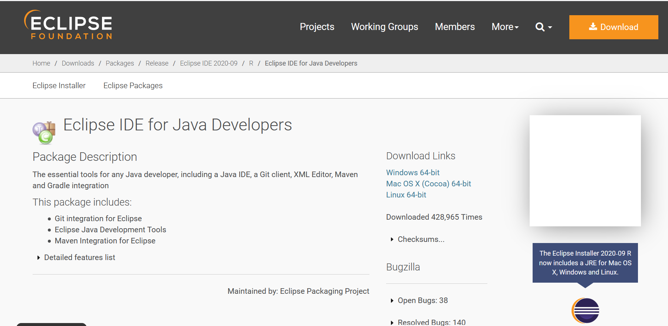

1. Once Eclipse has been successfully installed, open the IDE and go to Help > Eclipse Marketplace…

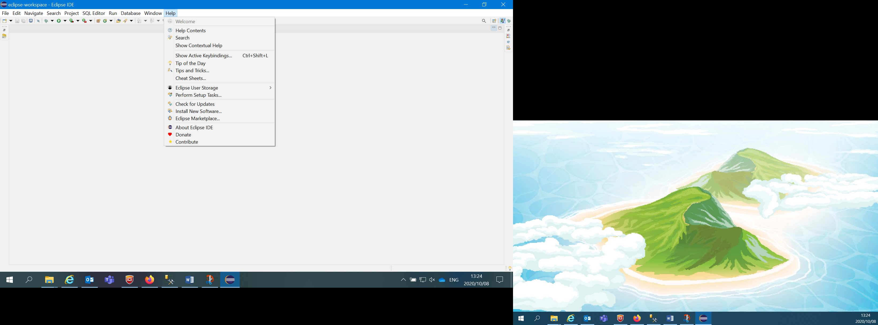

1. Search for “dbeaver sql” and click the install button for the extension DBeaver 7.2.2 (or latest version)

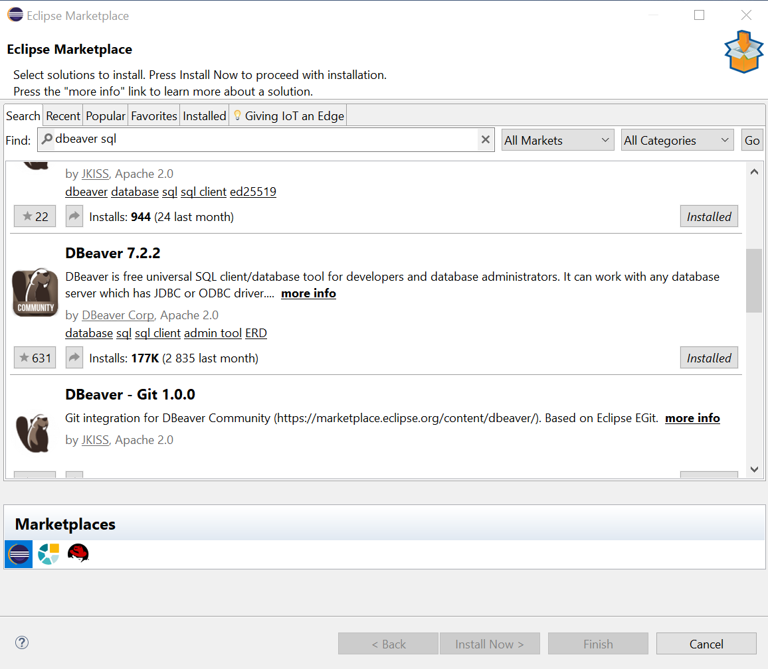

1. Follow the prompts to install the extension
2. Restart Eclipse if required
3. Go to Database > New Database Connection

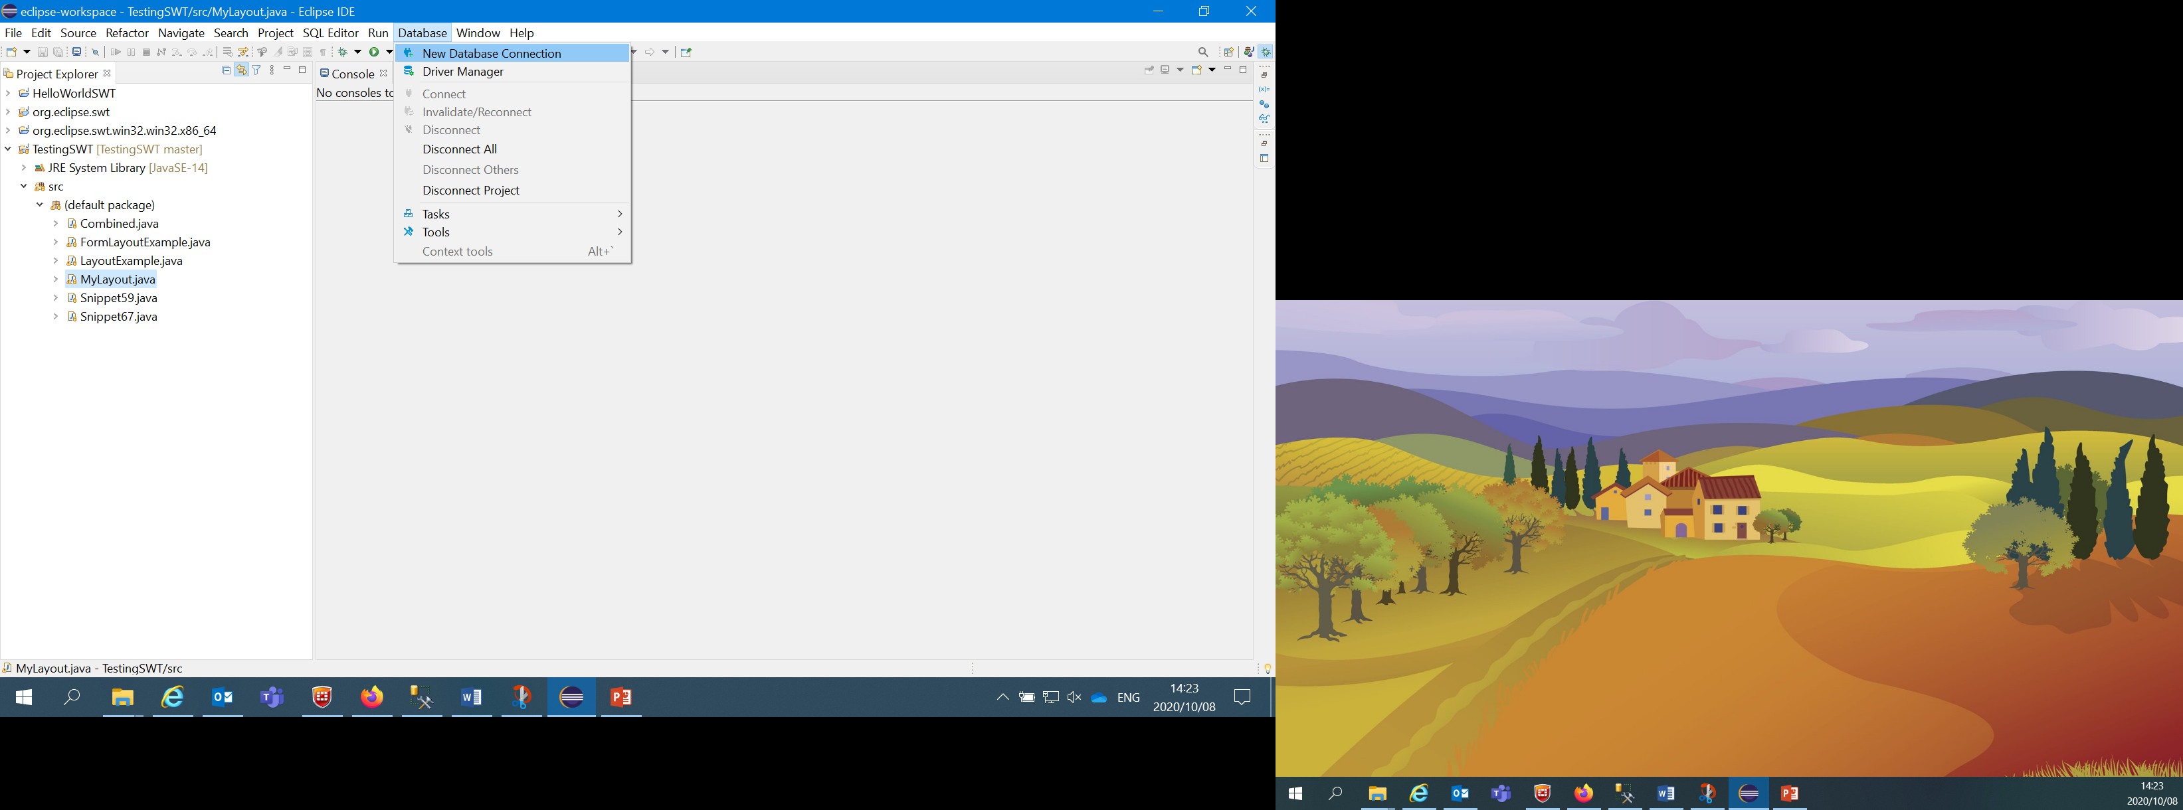

1. Fill in the details in the Main tab with:
   * Host: DEVSQL
   * Database/Schema: FOSMES
   * Authentication: Windows Authentication

and leave the rest as the default

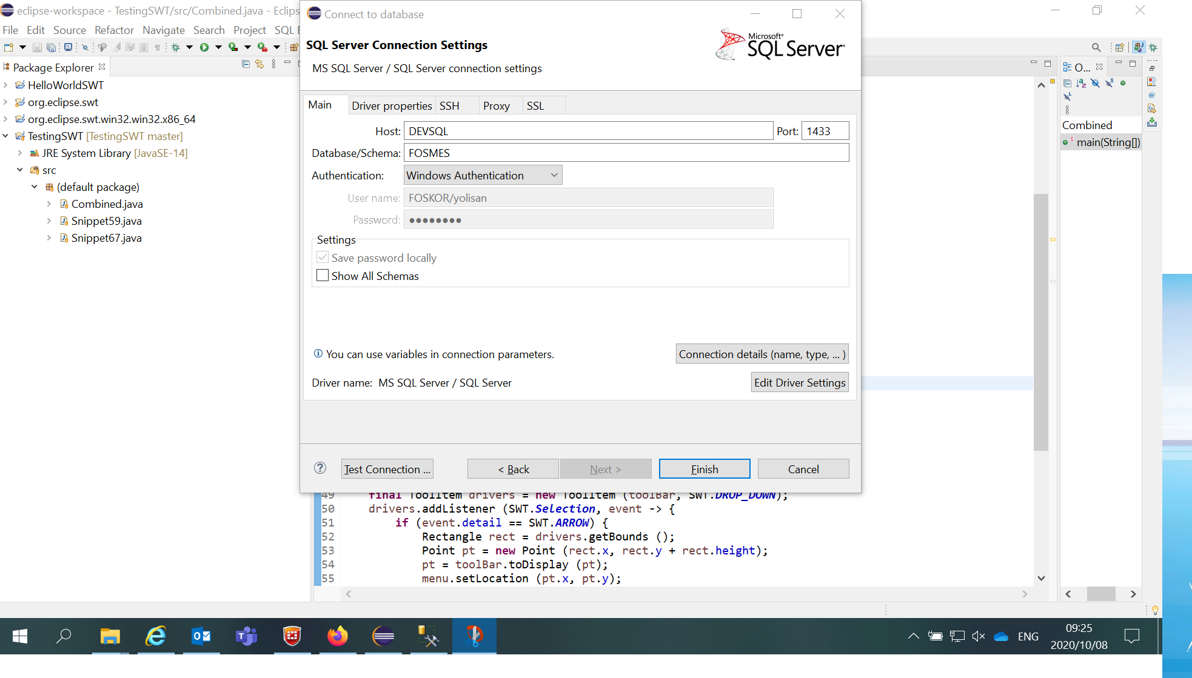

1. Check that the connection can be established by clicking on the “Test Connection…” button. If it is successful it should display a message saying it has Connected, along with the details of the connection. Click OK and then Finish.

